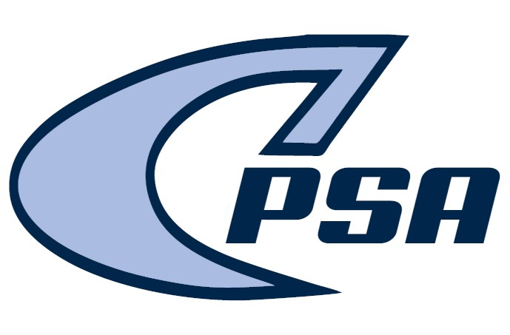
1000 Pro 3 Parkway St. Marys Ga 31558 Phone 912-510-7385 Email: kkwilliams@camdenpsa.com
2023-2024 BASKETBALL INFO FOR AGES 4-17

Must be this age prior to September 1, 2023
c PLEASE READ All THE INFORMATION ON THESE PAGES

Coaches please download Sportsyou app and join CPSA BASKETBALL COACHES:
Code is A9HK-HP74

The Youth Recreation League Basketball is a winter program for children to play Basketball. CPSA solicits volunteer coaches and assigns children to teams, according to age and skill level by using a draft. You may request a certain coach or team in 4-6 basketball. They are expected to attend and participate in all practices and games of the team they are assigned. All teams will play a minimum of 8 to 10 games depending on your particular age group. A request for a particular basketball team or coach will not be honored. If you have had issues with a former coach and do not wish to return to that team you may request to re-enter the draft and be drafted on to another team. Any hardship transportation request will be considered, but not guaranteed by staff for placement with a particular team.
The 4-6 age groups do not have skills evaluations in basketball. The Basketball coaches will receive their rosters no later than Friday Dec 4th Basketball practices should begin on or before Dec 6th . If you haven’t heard from a coach by Dec. 8th, please call the athletic office.

Skills Evaluation schedule:
AGE | DATE | TIME | PLACE
All 14u Boys | Nov 27th | 5:30 -6:30PM | CAMDEN REC. GYM
All 17u Boys | Nov 27th | 6:30 -7:30pm | CAMDEN REC. GYM
ALL 7-10 Girls | Nov 28th | 5:30 – 6:30PM | CAMDEN REC. GYM
ALL 11-14 Girls | Nov 28th | 5:30 – 6:30PM | CAMDEN REC. GYM
All 12u Boys | Nov 28th | 6:30 – 7:30PM | CAMDEN REC. GYM
KD 8u Boys | Nov 29th | 5:15 - 6:15PM | CAMDEN REC. GYM
KD 10u Boys | Nov 29th | 5:15 - 6:15PM | CAMDEN REC. GYM
SM 8u BOYS | Nov 29th | 6:30 -7:30PM | CAMDEN REC. GYM
SM 10u BOYS | Nov 29th | 6:30 -7:30PM | CAMDEN REC. GYM
If there are only enough kids registered for one team in a particular age group, there will not be a skills evaluation for that age group/city. All kids will be notified if it happens.

Coaching:
- Anyone 18 years old and over may apply to be a volunteer coach.
- New, former and previous coaches must fill out a coaching application and return it to the athletic department for every season you desire to coach.
- All coaches are approved by the athletic department EACH season.
- THE PSA ATHLETIC STAFF RESERVES THE RIGHT TO REJECT ANY COACHES’ APPLICATION.
E All prospective coaches will be expected to submit to a criminal background check and provide a valid drivers license. PLEASE TURN IN BACKGROUND WITH HISTORY.
F. All head coaches must complete a NYSCA certification clinic.
G. PLEASE TURN ALL PAPERWORK IN AT ONE TIME.

Being a youth coach involves teaching the sport, organizing practices, communicating with the parents about practice times and game times, finding a sponsor to cover the cost of uniforms, and appointing a team mom. The team may want team pictures and end of season trophies which is optional. If the team does want these things the parents are responsible for their cost.

Coaches must help run the skill’s evaluation for their age group so that they will be familiar with the children who are going to be drafted. Please be sure you understand what you need to do for the skill’s evaluation. Coaches are asked to help with the skill’s evaluation of other age groups, when we do not have all the coaches we need in that age group. All paper work given out at the skill’s evaluation must be returned to the athletic staff person at the end of each age groups evaluation.
The Coaches meeting will be Wed Nov. 15th 2023 at the Soccer Complex at 6:00 –7:00pm. The team drafts will be held on Nov 29th – 30th (subject to change) . Schedule is below.

ALL COACHES HEAD and ASSISTANT MUST ATTEND THE COACHES MEETING. ONLY HEAD COACHES TO THE DRAFT MEETING.
Please plan to attend this meeting, if you want to coach or help with a team.

Rules and other aspects of the game will be covered at this meeting. Please get your coaches application to us before this date so that we may be sure to have enough certification booklets for everyone.

ZERO TOLERANCE POLICY:

Profanity, Tobacco, Drug and/or Alcohol use, any verbal or physical confrontations will not be tolerated. Any coach, official, or spectator violating the zero tolerance policy could be subject to a one year suspension from all CPSA Activities. The CCPSA Athletic Department is committed to providing a safe and orderly family atmosphere of friendly competition and sportsmanship. We will not hesitate to use all resources at our disposal to ensure such an atmosphere is maintained at all of our events.

